STATUS OF TB SERVICES

Covid 19 pandemic has posed challenges to the health care services statewide. While we fight the pandemic with all our strength, it is important to see the access to TB care services are maintained without interruption. TB patients are at increased risk of missing diagnosis and unfavorable treatment outcome during Covid 19 pandemic. While all individuals are encouraged to stay at home and follow the government orders on state lock-down, health system has to ensure that the health care services are maintained uninterrupted.

So, a guidance document was issued to ensure that the interruptions to TB care service delivery in the state is foreseen and prevented on 25th March 2020 followed by an advisory for diagnostic service delivery on 27th March 2020. An updated comprehensive advisory from Principal Secretary (Health), Government of Kerala on continuing TB care during COVID-19 pandemic has come out on the 20th of April. All districts are advised to follow the advisory strictly with detailed action taken report collected and regular follow up being conducted by the State TB Cell.

STATUS OF TB SERVICES

TB Notification has come down in the state especially in the private sector since the second phase of COVID 19 pandemic. Total percentage decline since 18/03/2020 as compared to 01/01/2020 to 17/03/2020 is 58.8% ( Public 56.8% and private 66.31%).

DAILY TB NOTIFICATION FROM JANUARY - 3rd MAY 2020 KERALA (as on 09/05/2020)

Total Public Private
120

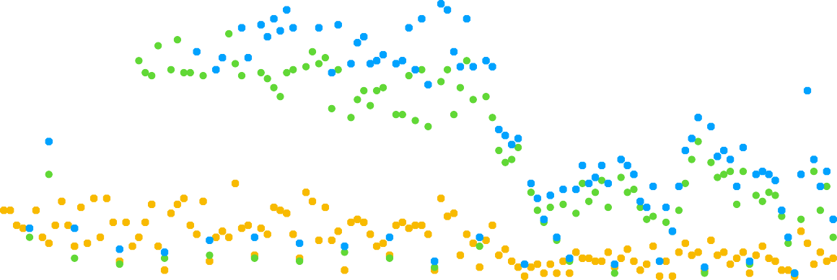90

60

30

0
28/12/19
05/01/20
14/01/20
23/01/20
01/02/20
10/02/20
19/02/20
28/02/20
08/03/20
17/03/20
26/03/20
04/04/20
13/04/20
22/04/20
01/05/20
10/05/20

Diagnostic Services

Weekly Smear Microscopy Examination rate (per lakh population/ week)
30
28.7 Kerala

22.5

15

7.5

0
25.1
24.8

19.8

8

6.6

6.5 7

8.2

7.1

- Presumptive TB examination though smear microscopy is showing a decreasing trend. It has fallen from an average of 28.7 tests per lakh population/week in February 2020 to 7.02 tests per lakh population/week in a period of seven weeks.

However, there is a slight increase on referral for presumptive TB examination at the OPDs by 1.89% in March 2020 as compared to 2019.

No of presumptive TB cases examined for diagnosis per week (in absolute no)

February 2020  average weekly | March 1 -  March 7 | March 8 -  March 14 | March 15 -  March 21 | March 22 -  March 28 | March 29 -  April 4 | April 5 -  April 11 | April 12 -  April 18 | April 19 -  April 25 | April 26 -  May 2
9801 | 8564 | 8465 | 6738 | 2749 | 2260 | 2219 | 2393 | 2794 | 2429

280 266

210
204

234

219

168

No found to be positive No entered in Nikshay

170

140

70

151

98 106
94 92

102

85
131

110

160
144

138

0

- The state used to offer on an average 1600 CBNAAT tests per week until February 2020, which is reduced to an average of 661 tests per week since mid-March 2020.
- There is a 50% decline in the LPA and CDST tests numbers.

Challenges

- Specimen collection and transportation mechanisms were disrupted owing to the nationwide lock down
- Shortage of PPE for key staff at the periphery
- Delayed enrolment in Nikshay as concerned staff are involved in COVID 19 response activities

Measures taken

- NTEP staff to aid in specimen collection and transportation within the districts
- Specimen to be transported along with the COVID specimen if transportation outside the district is required for CDST services
- Local purchase of PPE according to the COVID burden of the area/district
- Instruction given to districts to speed up pending Nikshay entries

Treatment Services

- All the diagnosed patients are put on treatment as per the programme guidelines.
- Other state patients who got stranded in Kerala are also supported for drugs and follow ups by concerned districts.
- All patients are given one month supply of TB/ co-morbidity medications at their door step.
- Any patient needing a direct physician consultation is provided ambulance services for transportation to the concerned health care facility.
- Separate shelter homes are identified for homeless TB patients

Monitoring activities

- Continuum of care is ensured using a three tier monitoring system at TB unit level, district level as well as state level. This monitoring check up on aspects like adherence, drug availability, adverse drug reactions, airborne infection control measures and timely management of co- morbidities. If any of the above aspects are found to be affected, immediate measures are taken up to resolve the concerned issue.
- The report on the weekly monitoring activities and action taken report on issues identified are sent to STO for supervision.
- More than 3000 such monitoring calls are made at TU level, 1000 calls at district level and 250 calls at state level are made in the past four weeks in this regard.

Public Health Action

- Public health action is provided to all patients who are currently on treatment, however DBT (with less than 1% paid beneficiaries for March 2020) services are affected due to the state's financial crisis.

Supply Chain Logistics

- The drug and lab consumable position is monitored by STC on a weekly basis.
- All drugs are available with 2 months stock at both SDS and DDS' except for Linezolid 600mg and Moxifloxacin 400mg for which the state has only 1.5 months supply.
- CBNAAT cartridges are available at all sites with a stock for two months.
- The lab consumables are available at IRLs and periphery for 1.5 months. CDST lab at Kozhikode has sufficient lab consumables stock for two months.

Expansion of SARS CoV-2 diagnostic services using NTEP diagnostic mechanisms

There are four laboratories with BSL2A2 identified for Xpert Xpress-SARS-CoV-2 testing. Concerned HR has been trained for the same and testing is being carried out since 24th April at three sites and 27th April at one site. A total of 296 samples are processed with three positives as on 09/05/2020.

