
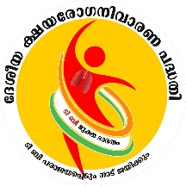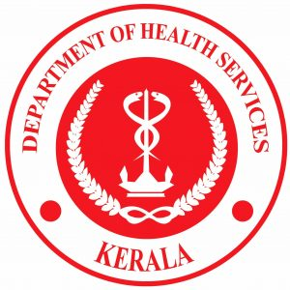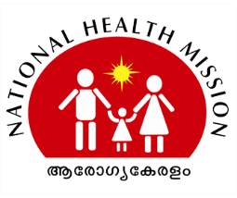
NTEP Kerala 2021

Best practices
&
Success stories


STATE TB CELL
Red Cross Road, General Hospital Jn.
Thiruvananthapuram –695 035, Kerala
Tel .0471 -2466058, E-mail:stoke@rntcp.org

NTEP Kerala 2021

STATE TB CELL
Red Cross Road, General Hospital Jn.
Thiruvananthapuram –695 035, Kerala
Tel .0471 -2466058, E-mail:stoke@rntcp.org

Lay out Design Satheesh joy ACSM Officer
Best practices
&
Success stories



Best practices & Success stories under NTEP Kerala 2021

Dr.Sunil Kumar M, State TB Officer, Kerala

In this COVID pandemic situation, for the patients who couldn’t access the Peripheral health institutions, NTEP kerala provided TB services at their door steps. Trained ASHA workers screened the vulnerable individuals and collected samples from the symptomatic. The samples were transported to District TB Centres for NAAT test by the transportation mechanism implemented in our State. The state has rolled out the upfront NAAT testing policy to the TB vulnerable individuals with the help of 74 & 40 Trunat & CBNAAT machines in the public sector.
Kerala State initiated TB Preventive Therapy among children & adolescents.1000 practising paediatricians across the state were trained using a 2.5-hour online module by 20 Trainer of Trainer’s with the coordination of IAP. Blood samples were collected from children and were transported to IGRA testing sites. IGRA positive children were referred to paediatrician for ruling out active TB. A total of more than 1000 samples were tested (household contacts, 5-15 years) and children were found eligible to be initiated on TPT 20.3% .Kerala implemented the bidirectional screening among the ILI & SARI for covid & TB.Presumptive TB Examination conducted through intensified case finding among Migrants, Destitute Homes. Workplace intervention and case finding among vulnerable population also conducted. State has also collaborated with other systems of medicines for the betterment of patients.
Thiruvananthapuram District started virtual monitoring of TB patients on 22nd October 2020 .The meetings were held twice in a week. Two key NTEP staff are appointed as the nodal officers, namely the Treatment Organiser and Sr. DR-TB Co-ordinator. Two TB patients on first line medication and one patient on drug resistant TB medication were invited for every meeting. Patients from each TU were invited on a rotation basis and thus it is ensured that all the seven TB Units are covered. The meetings were attended by District TB Officer (DTO), Medical Officer TB Elimination (MOTE), Senior Treatment Supervisors (STSs) and TB Health Visitor (TBHV). The patient’s family members were allowed to attend the virtual meeting.
Kollam District, has effectively implemented a sample transportation technique by utilizing the manpower and service of ASHAs throughout the district. Initially, an average of two ASHA from each health block were empanelled as “TB Sample Collection Staff” and assigned to the public and private health institutions for the collection purpose. Incentives for them were fixed depending upon the distance from collection centre to the respective NAAT sites and Sample carrying kits are provided for transportation of specimen. The ASHA also ensures the timely dispatch of the lab test results on her each visit to NAAT site.
Pathanamthitta District, Ranni TU join hands with NGOs and Welfare Association to provide nutrition support to the needy. The association representatives who have expressed his willingness to continue their services to the needy as part of the TB Elimination program.
District TB Centre Kottayam in collaboration with Akshaya Trust,(a socially responsible trust to help the poor suffering from tuberculosis and HIV infection in Kottayam district) is providing services like social security to patients which includes financial support, aiding patients to make a stable income, financial assistance for the education of children in the family and activities to promote hope and optimism among the patients and their family. The Trust also undertakes awareness and counselling activities to reduce the co-morbidities associated with TB like alcohol, tobacco etc and to prevent the spread of the disease from one person to the rest of his family and into the community.Active case finding activities like screening camps for migrant workers (64 camps) and TB-COVID19 bidirectional screening (3150 migrant workers) were also conducted.
Idukki District When COVID pandemic hit the country lockdown implemented to combat COVID-19 has greatly affected NTEP ACSM activities. District took innovative ACSM methods to inform the people about the changes and adaptation in NTEP program to overcome the challenges brought by the pandemic. The documentary film “Fight like Raziya” made in conjunction with it had won best entry film in the segment “Catalysing Behaviour Change” of National IAPSM Young Leader’s Conclave 2021.
The routine NTEP activities were also affected due to the pandemic, NTEP team in Idukki had come up with innovations at every step when they were faced with challenges. Telephonic active case finding, door-step-delivery of NTEP services and regular follow up of vulnerable individuals were done by NTEP staff. Similar to Akshaya Keralam catch up campaign NTEP Idukki has initiated post- COVID TB screening in a campaign mode to ensure that bi-directional TB-HIV screening is done . Instruction was given ASHAs to conduct ward level screening of all post COVID patients in the past 6 months and collect samples of those who complain of persistent respiratory symptoms. District sputum collection and transportation machinery will collect and transport the samples to the nearest GeneXprt lab. Field staff was instructed to monitor this activity and the reports have to be collected and submitted in a prescribed Post Covid-19 screening format . Periodic review of these activities were done at TU level by field staff and at District level by DTO.
District TB Centre Thrissur Intensified case finding activities were conducted among Migrants , Destitute Homes, coastal places, tribal areas and Vulnerable population of the District. Workplace intervention were conducted in 15 different places, under all treatment unique and no positive cases were detected . As a part of bi-lateral COVID19 and TB screening Asha workers screened ILI and post Covid cases and 7445 samples were collected. Of the tested sample 25 TB cases were detected.. Screening of paediatric contacts (Under 15 years old) of 4 Pulmonary TB cases was also done and all were screened negative. H1 Campaign and IGRA based TB infection detection were also being conducted in the district.
District TB Centre Kozhikode has implemented a new programme named “KAIVALLYAM”- A Mission to reach out to TB patients who are alcohol/drug abusers in Kozhikode District. It is a joint initiative of District TB centre and OST centres under KSACS- Kerala State AIDS Control Society. Services like medical camps, Smoking Cessation programs psychological support and other related services were provided through Professional counsellors and District PPM Co-ordinator. Based on the meeting with District Collector it was decided to conduct TB screening and testing at destitute homes. TB screening activities were done for all inmates at ‘Udayam homes”(Udayam project a mild touch in the rehabitilation of street dwellers in Kozhikode District) and TB sensitisation classes were arranged for home manager, medical officer, nurses, and all staff in all three “Udayam homes” in the district.
As TB and HIV are among the major co-morbidities contributing to COVID19 infection fatality rate, prioritisation of COVID-19 vaccination for these grouo was the need of the hour.As on July 30th 2021 Nine COVID-19 vaccination camps were conducted and 1000 Beneficiaries were Vaccinated which includes EPTB, HIV, PLHIV, Destitute and Street dwellers.
Kasargod District TB Centre as a part of TB elimination,active case findings and TB IEC activities are being carried out in the District. As a part of TB-COVID19 bi-directional screening Falcon tubes were distributed to the Covid testing sites and COVID19 Vaccination site of District Hospital Kanhangad, Ukkinadukka Medical College, TATA Hospital Chattanchal, PHC Ennappara etc. For strengthening TB- covid19 bi-directional screening, sensitization classes were arranged all private hospitals under the jurisdiction of Kasargod TU. Considering the difficulty of TB patients to report to the concerned TUs due to the implemented lock-down, TB Medicine ,Nutrition kit and falcon tube (for follow-up examination) were delievered to the door step of the patient. With the help of Cyber cell the Kasargod DTC was also able to trace out an interrupted TB patient from Lathur district at Maharashtra and brought back into the programme..For highlighting the involvement of TB as a major co-morbidity in COVID-19 IEC activities like Banner Paper and Form Board in all PHCs in the district were also done.


Surveillance through Virtual meeting with patients

Thiruvananthapuram District

Virtual meeting with patients
The virtual meeting will start with general discussions and sharing. Once the rapport is built, patients would start sharing about the intake of medications, status of co-morbidities, the support provided by key staff and family supporters, and any other issues faced by them. Measures to address patients’ issues and concerns are initiated without fail. Patients will be given a sensitisation on variation in weight bands and need change of Fixed Drug Combinations (FDCs), adverse drug events, follow up schedule, managing co-morbidities, dietary requirements, Nikshay Poshan Yojna (NPY). The meeting will end with reassurance, advices and proper direction and reference in dealing with the co-morbidities if required. Feedback are given to the concerned Peripheral Health Institution (PHI) Medical Officer.

Objectives of the activity:
To provide social, psychological and physical support to the patients and thus ensuring early identification of factors that can lead to lost to follow up, treatment failure and death. To detect Adverse Drug Reactions (ADRs) early, effective management of co-morbidities and improve treatment adherence.

Thematic areas covered under the virtual monitoring : Age, address, weight, appearance and behaviour, family support, involvement of key staff, community support, functions of Treatment Support Unit, involvement of PHI, MO, Pharmacist, MPW, ASHAs. Any difficulty with initial phase of treatment, speech – quality of speech, tone and conversational boundary, affect – normal affect, flat affect, blunted affect, mood – normal mood, low mood, elevated mood, adverse events, follow up investigations,
- Fortnightly clinical reviews
- Follow up of comorbidities
- Adherence to NTEP medication
- Adherence to other medication
- Control of comorbidities
- Dietary status and advise
- Direct Benefit Transfer (DBT) status under NPY
- Possibility of drug interactions and ADRs
.
Major achievements
- Building rapport with the patients
- Promotion of a team work among NTEP and health system staff
- Improving the relationship with peripheral institutions
- Ownership and accountability of the NTEP key staff
- Boosting the ownership of the PHI
- Reassurance of the patients
- Improvement of co-morbidity management
- Improved patient satisfaction
As a result of interaction meeting DTU was able to support an MDR TB patient who was suffering from reduced oxygen saturation by providing him an Oxygen concentrator by the help of Treatment Support Unit.

Glimpses of Best Practices, Thiruvananthapuram
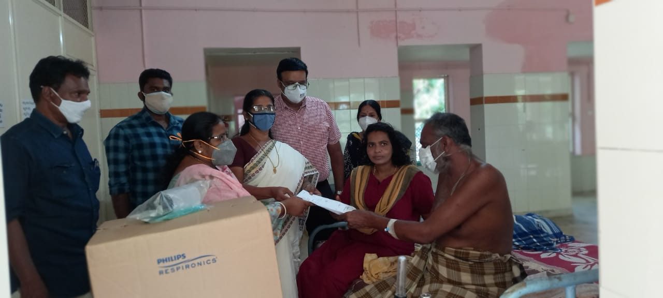
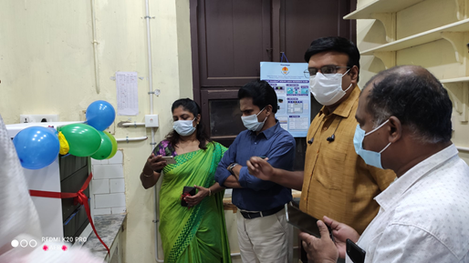
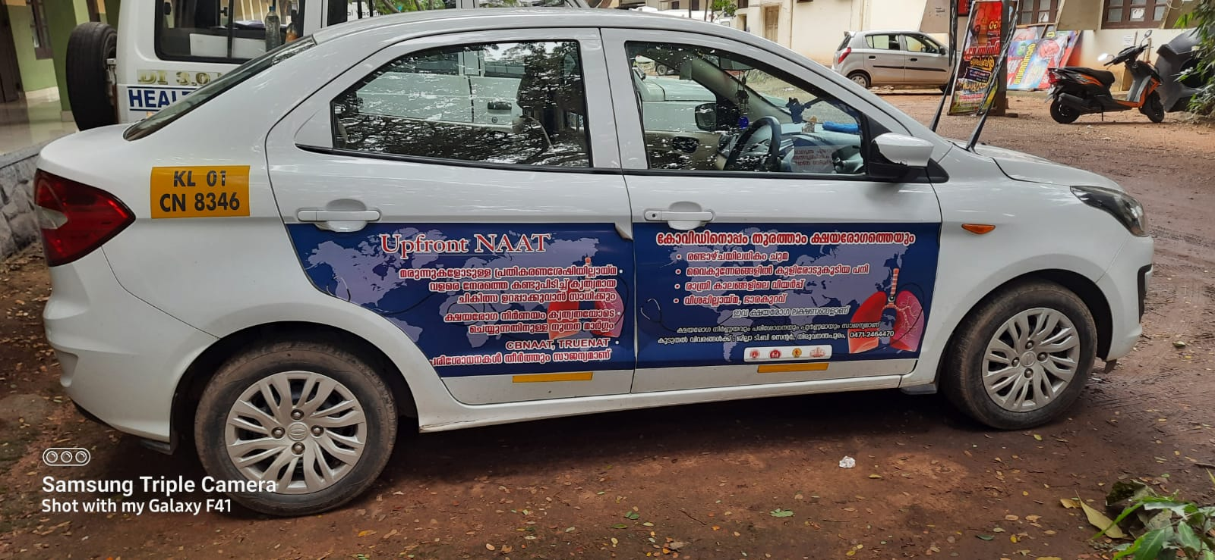
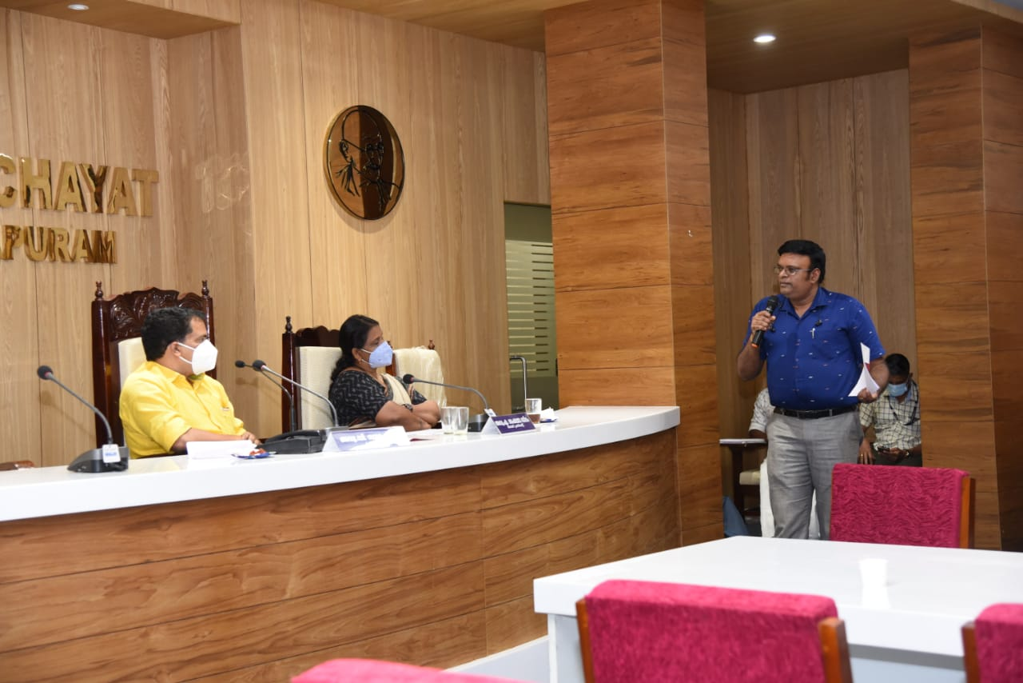
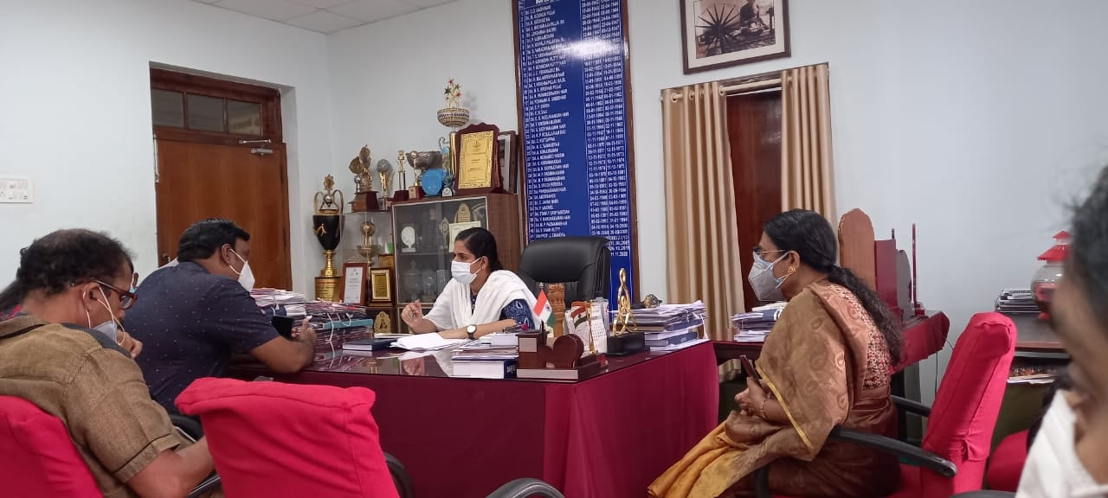
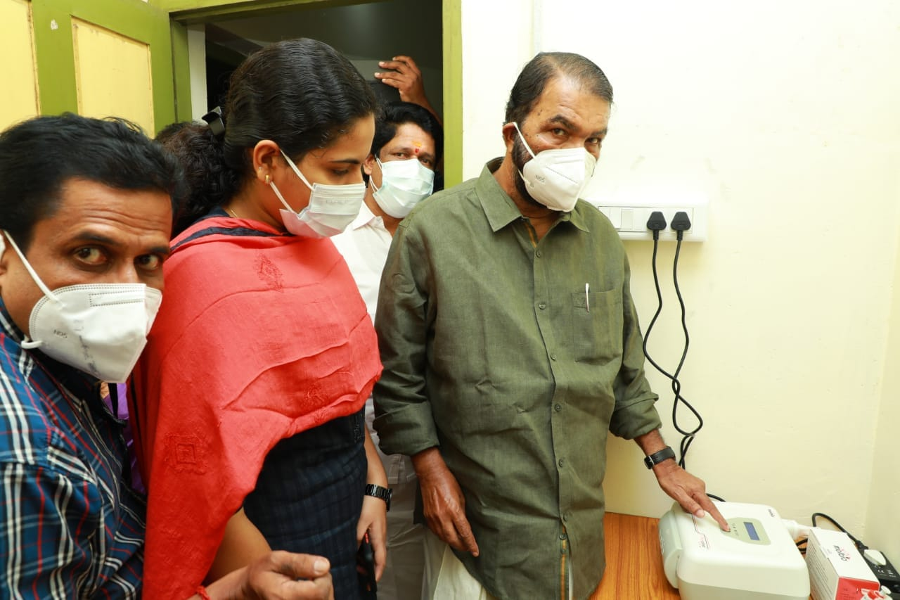
TB Laboratories and Diagnosis
Kollam District

Effective Implementation of Sample Transportation for Diagnosis and UDST
Kollam District, Kerala has effectively implemented a sample transportation technique by utilizing the manpower and service of ASHAs throughout the district. Initially, an average of two ASHA from each health block were empanelled as “TB Sample Collection Staff” and assigned to the public and private health institutions for the collection purpose. Incentives for them were fixed depending upon the distance from collection centre to the respective NAAT sites and Sample carrying kits are provided for transportation of specimen. The ASHA also ensures the timely dispatch of the lab test results on her each visit to NAAT site.
Benefits: Hence it is ensured zero delay for sample to reach NAAT sites is ensured and lab results are issued at minimum turnaround time via email. This practice benefited the health care providers and patients by facilitating speedy and timely diagnosis / UDST. This practice widely reduced the travelling difficulty of patients to the NAAT sites.

The ASHA handover the safely transported Sample to the staff concerned at NAAT site. The sample and test request, transported from various hospitals are scrutinized and received by the Lab Technicians at NAAT sites.

Picture (2) & (3) Lab technician receiving the sample from ASHA
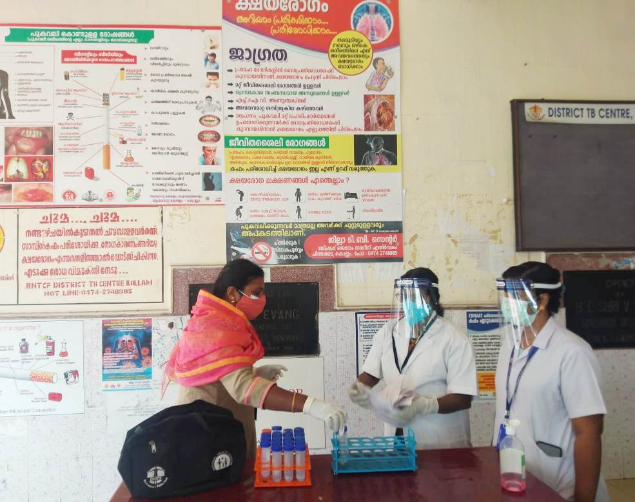
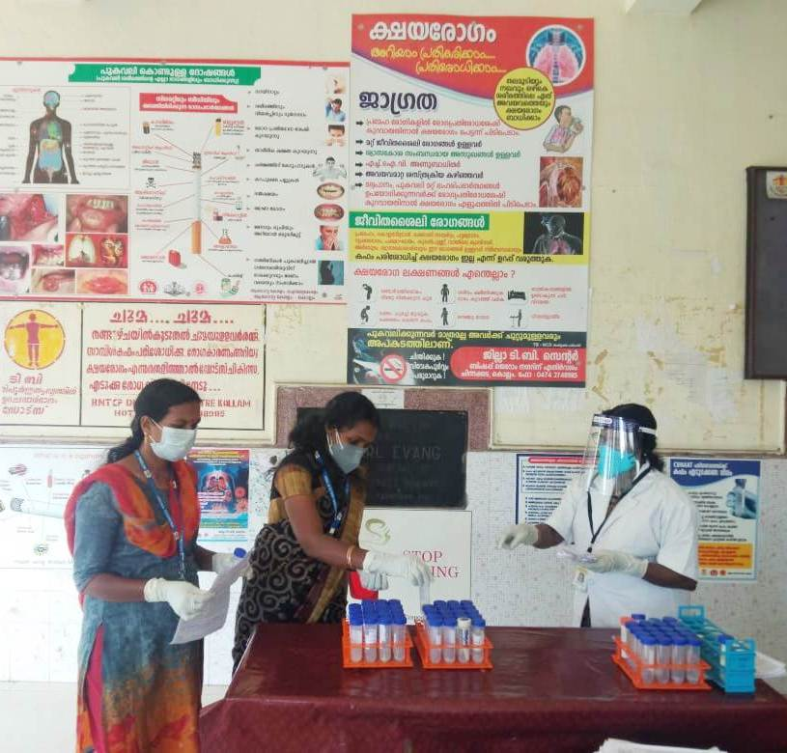
The ASHAs are telephonically intimated from the Health facility on receipt of sample from the Patients. The ASHA collects the properly sealed and packed sample from the health facility. This service is provided to both public and private sectors particularly at the STEPS centres

Picture (1) Sample collecting by ASHA from
KIMS Hospital (STEPS), Kollam Dist.

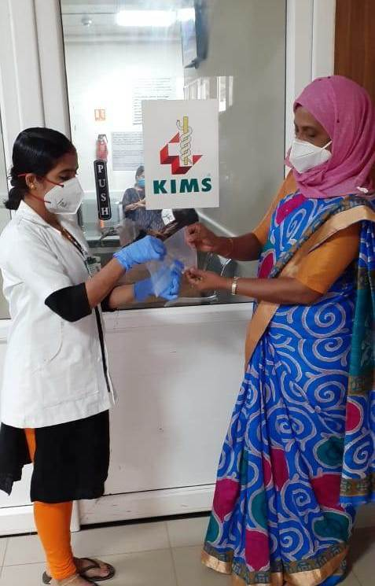
Community Engagement
Pathanamthitta District

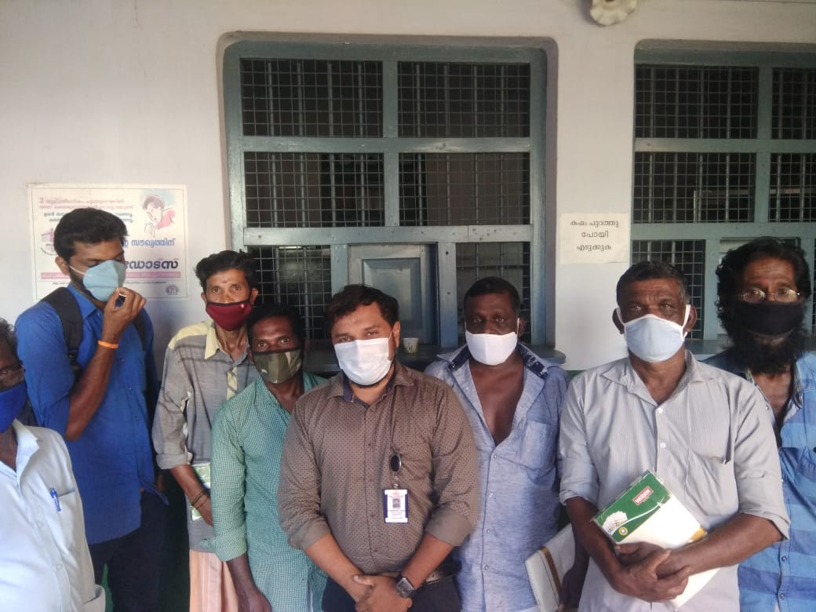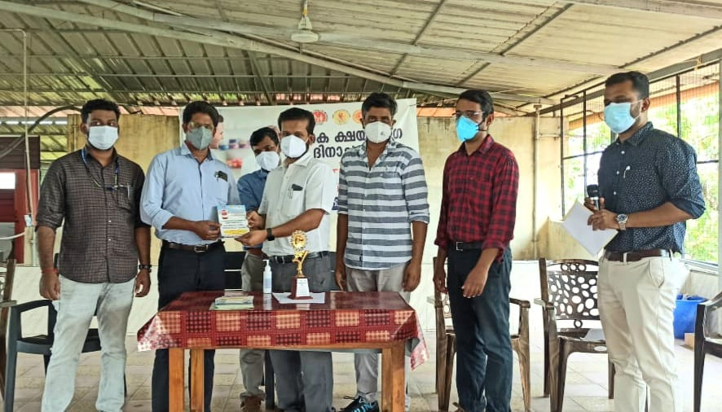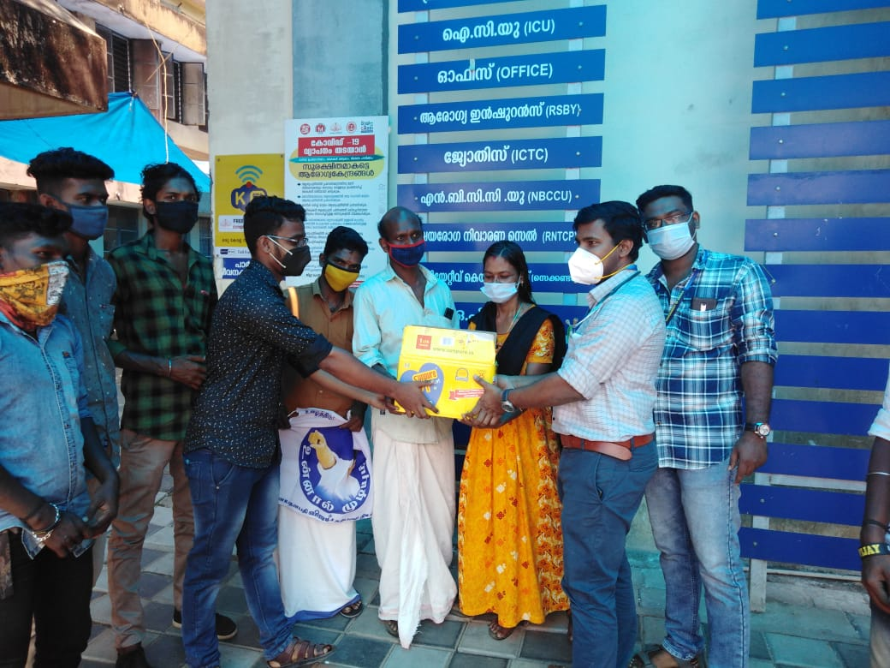
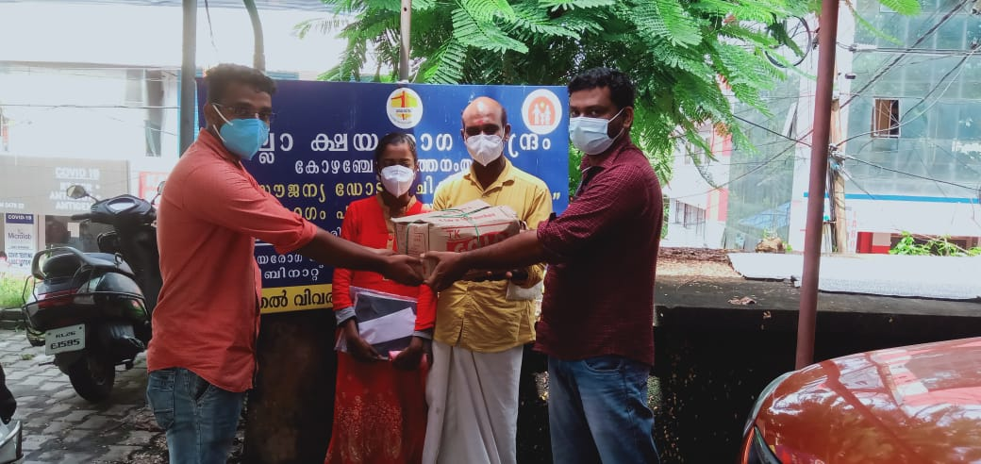
The emergence of TREATMENT SUPPORT GROUPS as part of the National Tuberculosis Elimination Program was in Pathanamthitta district. It was a step that was commended even by the World Health Organization. Socially and economically backward communities are living in the hilly areas of this District. Malnutrition not only increases the risk of tuberculosis but also causes treatment complications. Ranni TU in Pathanamthitta District join hands with All Kerala Dr. Thalapathi Vijay Fans and Welfare Association and provided nutrition support to the needy. The association representatives who have expressed their willingness to continue services to the needy as part of the TB Elimination program.


Social support schemes
Kottayam District

District TB Centre Kottayam in collaboration with Akshaya Trust,(a socially responsible trust to help the poor suffering from tuberculosis and HIV infection in Kottayam district) is providing services like social security to patients which includes financial support, aiding patients to make a stable income, financial assistance for the education of children in the family and activities to promote hope and optimism among the patients and their family. The Trust also undertakes awareness and counselling activities to reduce the co-morbidities associated with TB like alcohol, tobacco etc and to prevent the spread of the disease from one person to the rest of his family and into the community. Active case finding activities like screening camps for migrant workers (64 camps) and TB-COVID19 bidirectional screening (3150 migrant workers) were also conducted
.
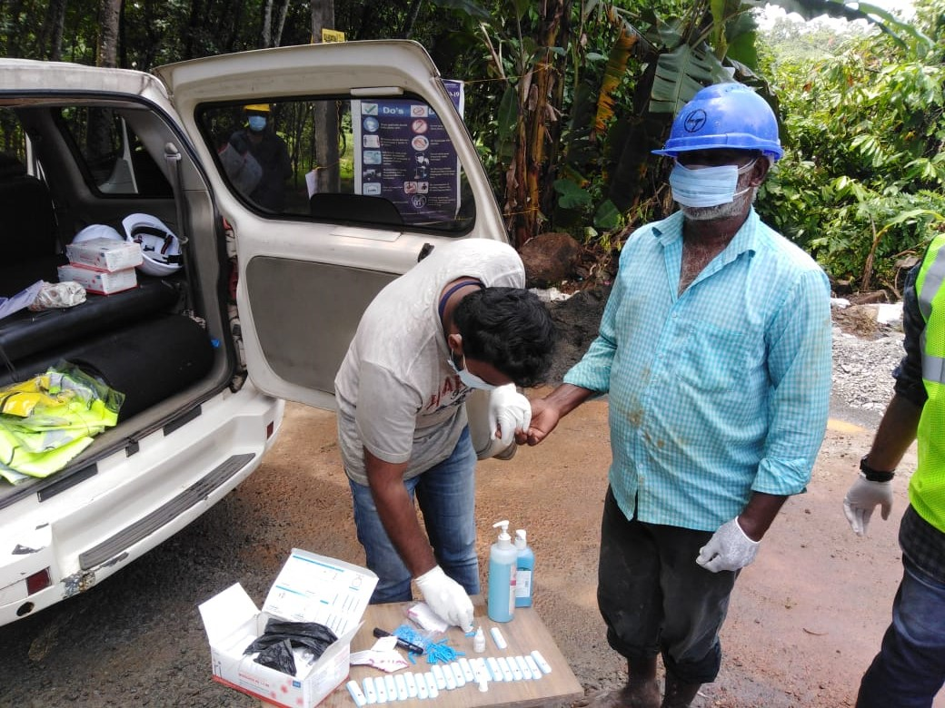
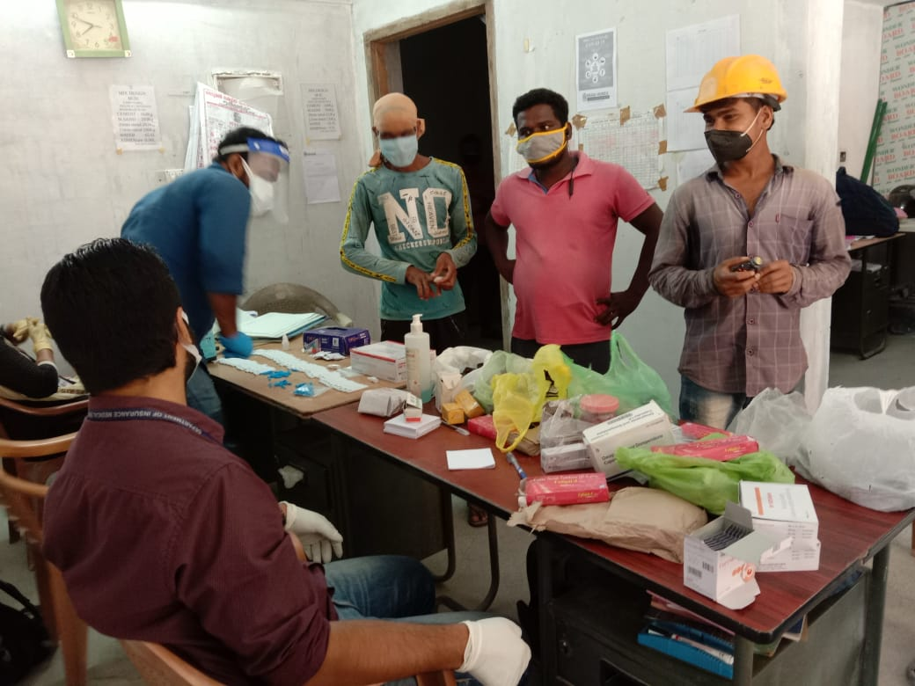
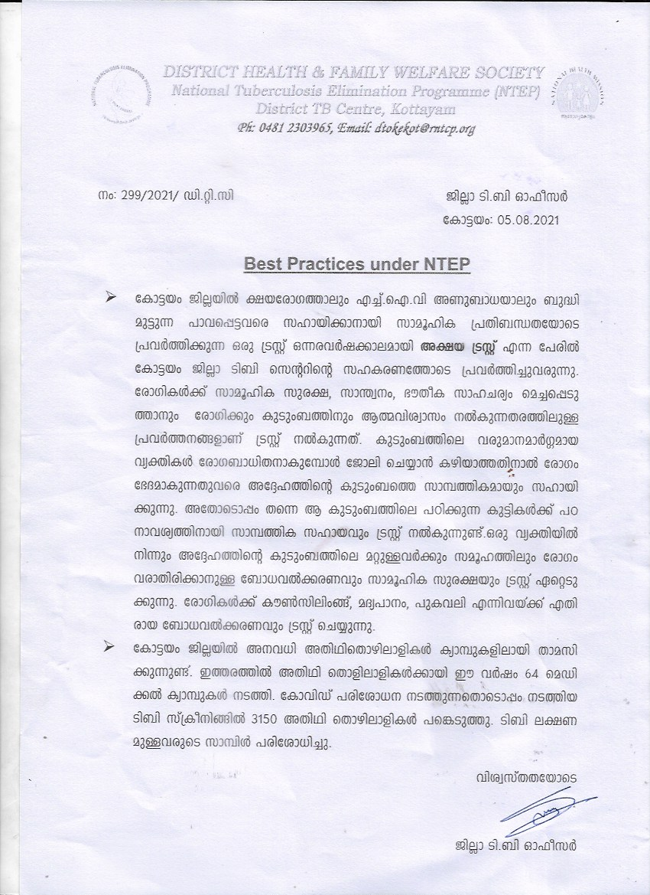
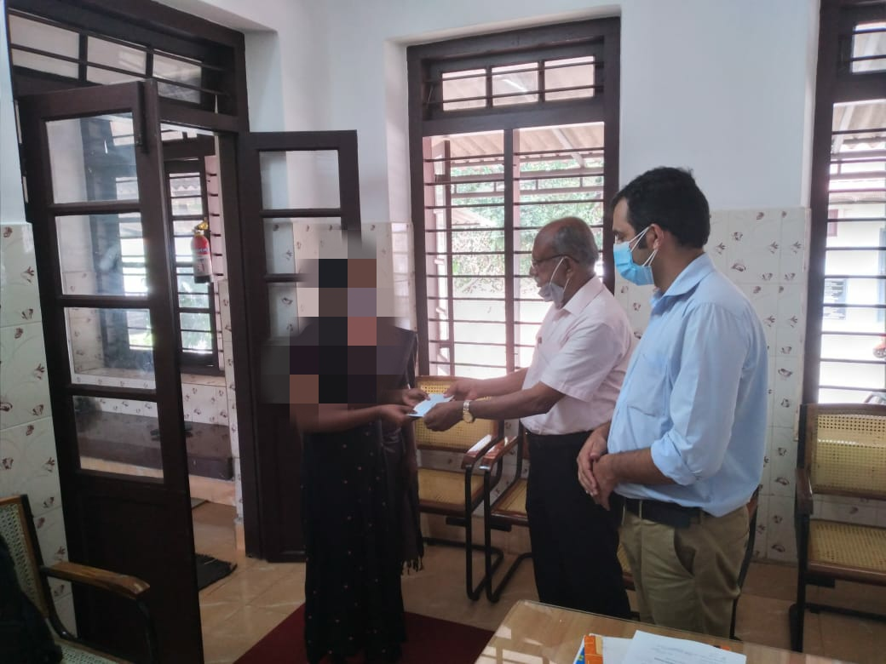
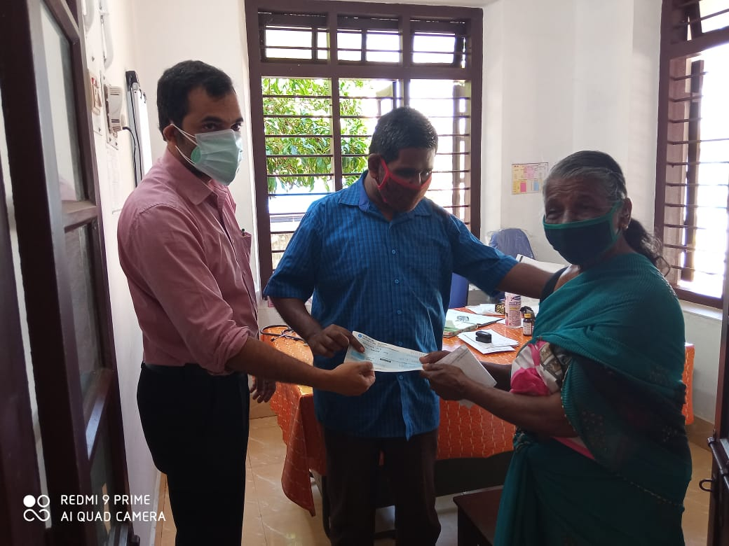

NO Best practices & Innovations

Article 1

Idukki District

Fight like Raziya – A short film created by DTC Idukki that catalyzed behavior change

When COVID pandemic hit our country along with the entire world, it threw our focus on NTEP ACSM activities off balance as we were in lockdown and the whole country was trying to manage the pandemic. COVID shows similar symptomatology as TB but this was not evident among those outside the medical community. It was imperative to spread this information among the masses and shed light to the reality that TB diagnosis may be overlooked while doing tests for COVID and the disguise can actually cause delay in diagnosis. While the health system had put timely guidelines in place like strengthening of ILI-SARI screening, bilateral COVID-TB testing and post COVID screening it was also important to conceptualize innovative ACSM methods to inform the people about the changes and adaptation NTEP program was making to overcome the challenges brought by the pandemic.

This thought led to the birth of the documentary film “Fight like Raziya” which was the brainchild of Dr.Cency B, DTO, Idukki. There was immense support from the State TB cell and WHO consultants. Information regarding COVID was flooding the mass media and people hungry for information relied on mass media like never before especially short educational videos. Therefore we decided that it was the best way to disseminate information. The story progresses through the life of a young girl and her father with an emotional touch. This docu-film caught the attention of then Health Minister K.K ShailajaTeacher who appreciated the team behind the film. The film also won the best entry in the segment “CatalysingBehaviour Change” of National IAPSM Young Leader’s Conclave 2021. The film was released through the facebook pages of District Collector of Idukki and an award winning actor.

The docu-film begins with the appreciation and introduction by the Health Minister, an award winning famous actor does the narration while the story progresses which gives the viewer a clear picture regarding COVID and TB. Towards the end of the film, the actor makes a special appearance and the District TB officer gives a short description on COVID and TB. The 6 minute long docu-film was viewed by over twenty thousand social media followed within a month. It also has sub titles in English for viewers outside Kerala since the content has relevance at the national and even international level. It continues to be an educational tool till date.

Article 2

Idukki District

Prevention

POST- COVID Screening for TB– Overcoming practical difficulties in the field.
Rugged mountains and forests cover about 97 percent of the total area of the Idukki, the second largest district in Kerala. This geography presents with unique challenges in TB elimination program in terms of planning and implementation. People rely on public transportation and public health delivery system through field staff especially those living in hard-to-reach areas. COVID pandemic affected the routine activities and restrictions like lockdown posed challenges in ensuring patient access to health care.
NTEP team in Idukki had to come up with innovations at every step when they were faced with challenges ensuring door-step-delivery of services and telephonic active case finding and follow up of vulnerable individuals by NTEP staff. AkshayaKeralam campaign gave momentum in reviving the weakened enthusiasm of the general health system towards TB case finding activity due to the undue pressure of managing COVID. TU and institution level training session was given to field staff and ASHA workers. The campaign was a success.
Almost two years into the COVID pandemic, we have learnt to live with COVID. NTEP activities cannot wait until COVID is over. This was further reminded when guidelines on post COVID screening were given.
NTEP Idukki decided to do post COVID screening in a campaign mode taking our learning from AkshayaKeralam catch up campaign. The campaign was decided to be conducted in July-August 2021. The aim was to ensure that all post-COVID patients will be screened by our system. An initial meeting by DTO with the NTEP staff finalized the method of implementation of Post –COVID screening campaign for TB. With the support of the District Medical Officer who chaired the district level sensitization session for MOs of Peripheral Health Institutions and field staff the program was inaugurated and officially set in motion. This was followed by institution level training for all ASHAs in the district by NTEP staff. ASHA workers have ward level list of post COVID patients. ASHAs were given training on the newer COVID related guidelines on TB elimination activities and infection control practices while doing field level TB screening among post COVID patients. The meetings were also chaired by DTO, representatives from LSGD, Charge Medical officer and (Medical Officer for TB elimination)MOTE and attended by field staff. Instruction was given ASHAs to conduct ward level screening of all post COVID patients in the past 6 months and collect samples of those who complain of persisting symptoms. These samples have to be taken to the nearest PHI from where the district sputum collection and transportation machinery will collect and transport the samples to the nearest GeneXprt lab and offer them upfront molecular testing at TruNAAT or CBNAAT sites. Field staff was instructed to monitor this activity and submit monthly report on Post-COVID TB screening format. TU level monitoring by NTEP field staff and district level monitoring by DTO will be done using the district level data on post COVID patients which is routinely being shared by the COVID control cell with the district TB centre upon our special request in order to have first had information on COVID patients and those under IP care in various hospitals. This was being done from the beginning of the pandemic anticipating the need of COVID data for TB elimination activities as these can be considered as vulnerable individuals.
In addition to this NTEP staff was given the list of post COVID patients of April-May 2021 and were asked to telephonically screen them for TB. The district level data from the COVID Control Cell was distilled at DTC level and was sent to each TU. Staff received immense positive response during telephonic screening. Post COVID patients appreciated our NTEP staff for conversing with them not only regarding screening but also for enquiring about their general well-being and also for giving instructions regarding any co-morbidity they were facing. Molecular testing was done on those with symptoms. None was diagnosed with TB.
Once the activity is over, we expect to identify missing TB cases, if any.
POST COVID Screening for TB Idukki.
Fight like Raziya-Documentary film Idukki
Glimpses of Best Practices, Idukki

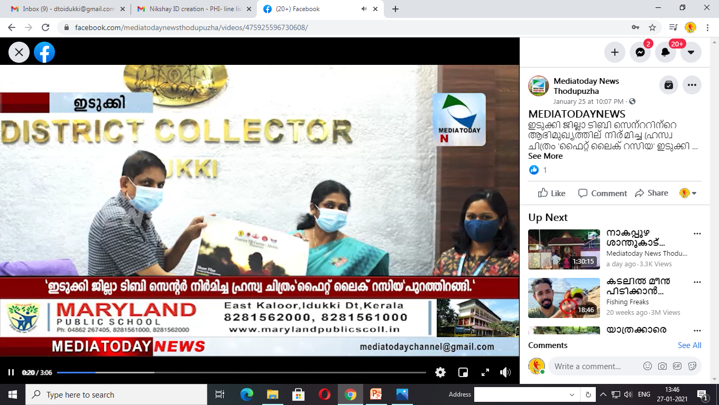
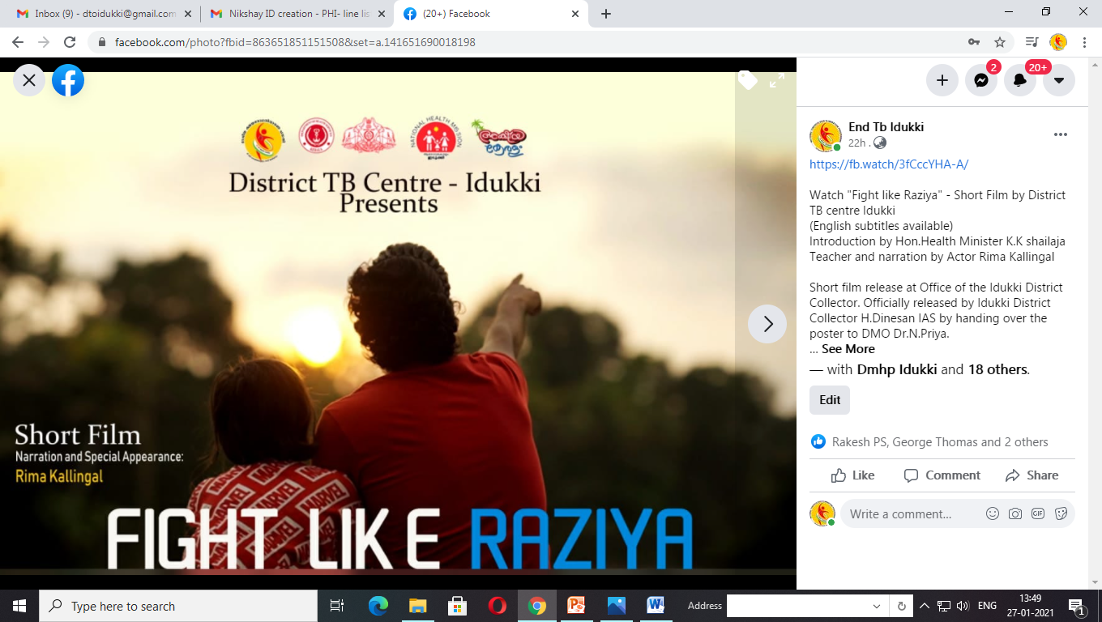
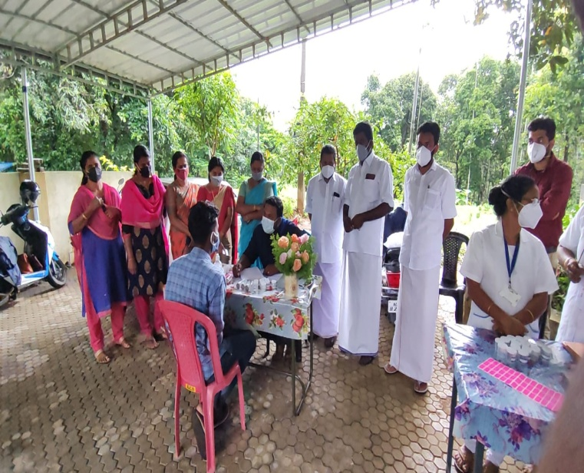
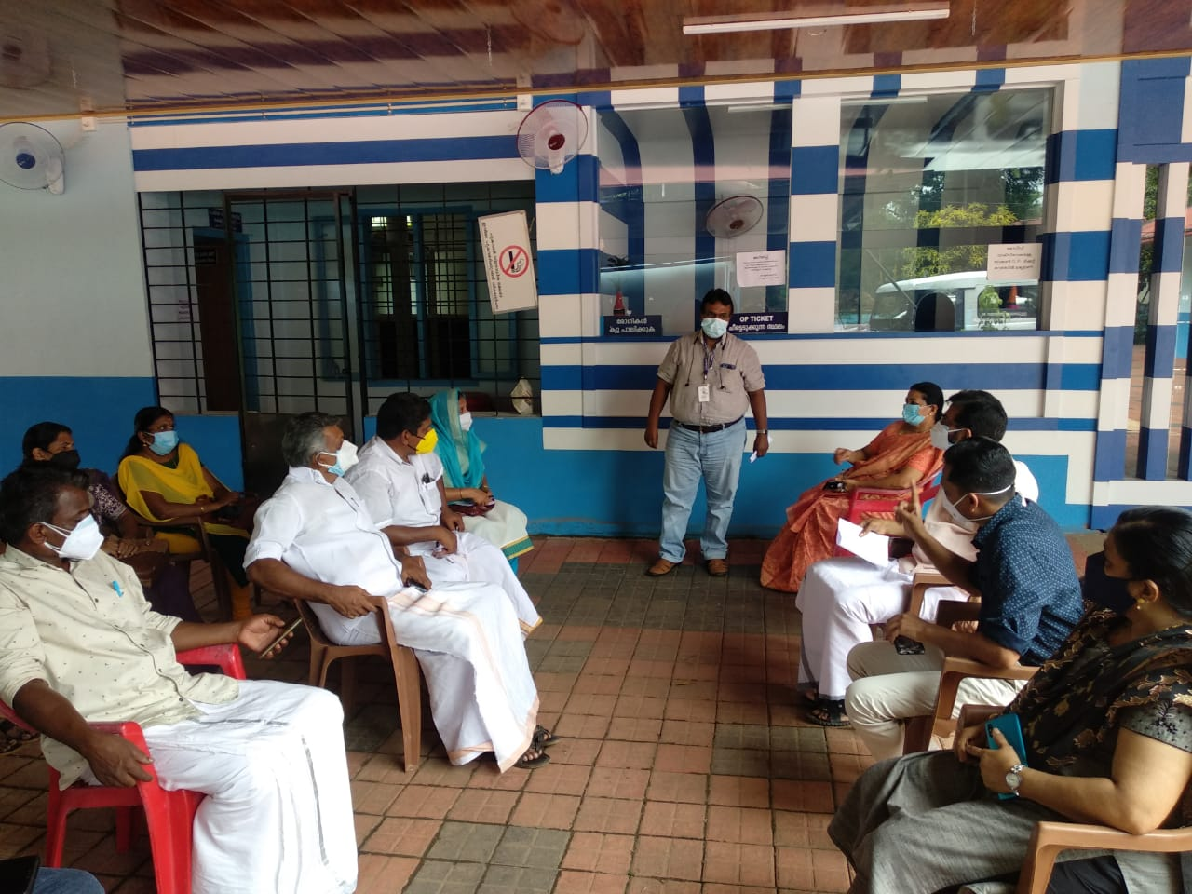

Prevention

Thrissur District

Presumptive TB Examination conducted through intensified case finding among Migrants , Destitute Homes and Vulnerable population of the District.
Workplace intervention conducted in 15 different places under all treatment unique and no positive cases detected. ICF among mahouts Guruvayur Punnathurkotta , Costal places , Tribal area , Vettilapara – vachumaram – Anakayam colony .
Asha workers screened 7445 samples from ILI and post Covid cases and detected 25 positive from the field. They also screened children under 15 four pulmonary TB and not found any positives from them.
- H1 Campaign conducted in the District.
- IGRA initiated in Govt. Medical College, Thrissur.
Harbor
Screening
Munabam

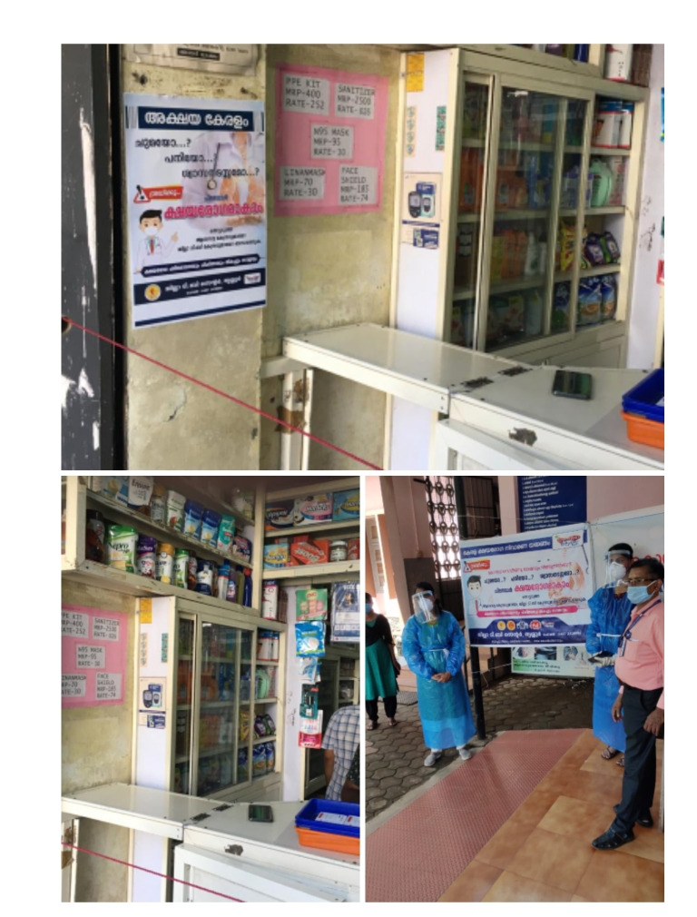
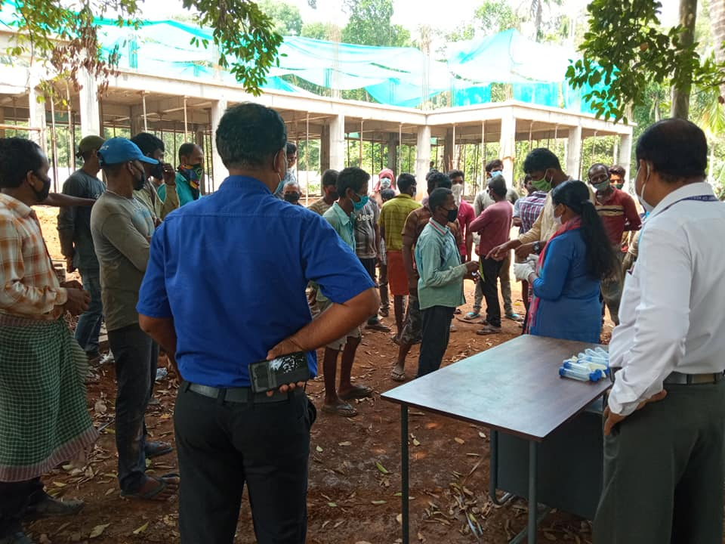

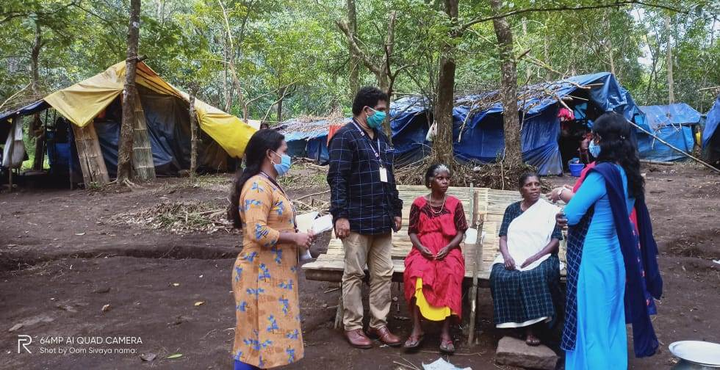
Tribal Colony –Vachumaram & Anakayam
H₁ Campaign
Workplace intervention & Migrant Screening
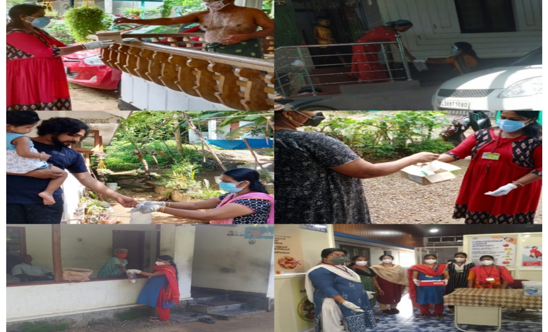
IGRA TEST
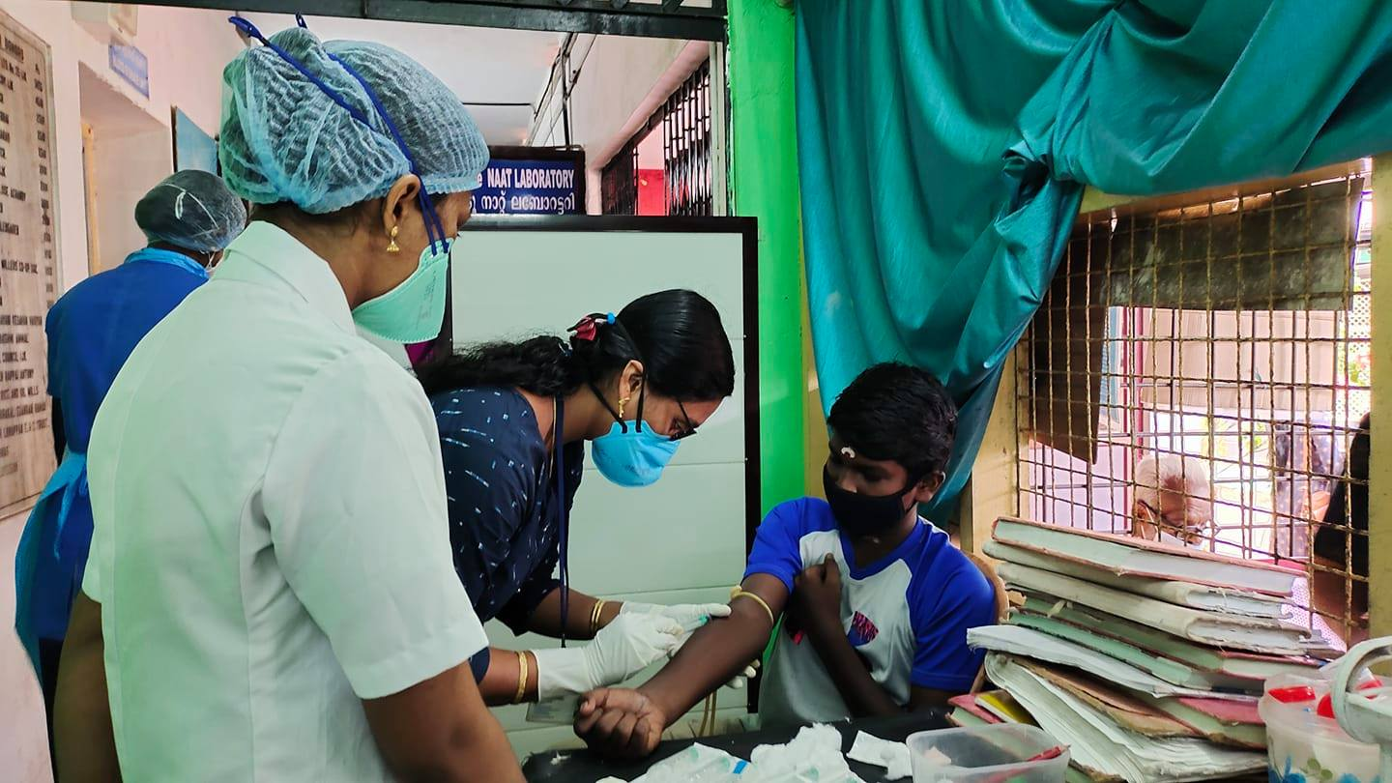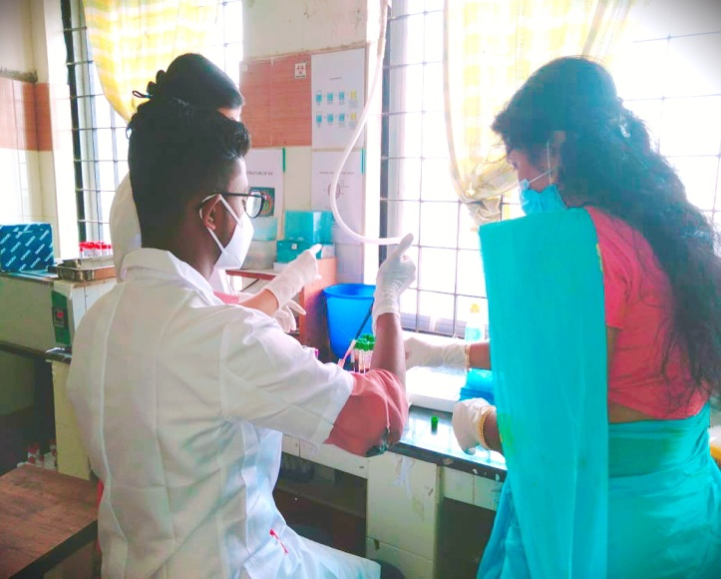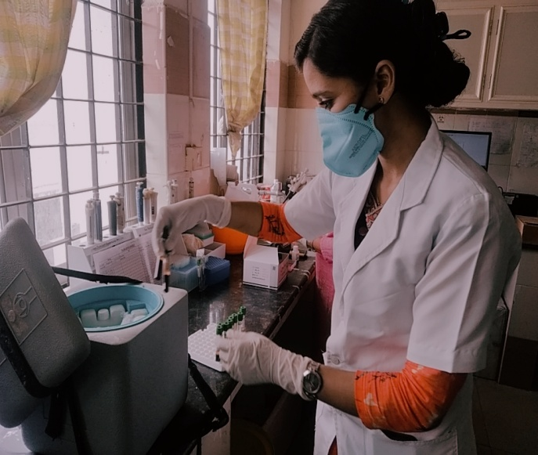
ILI Sample collection by Asha
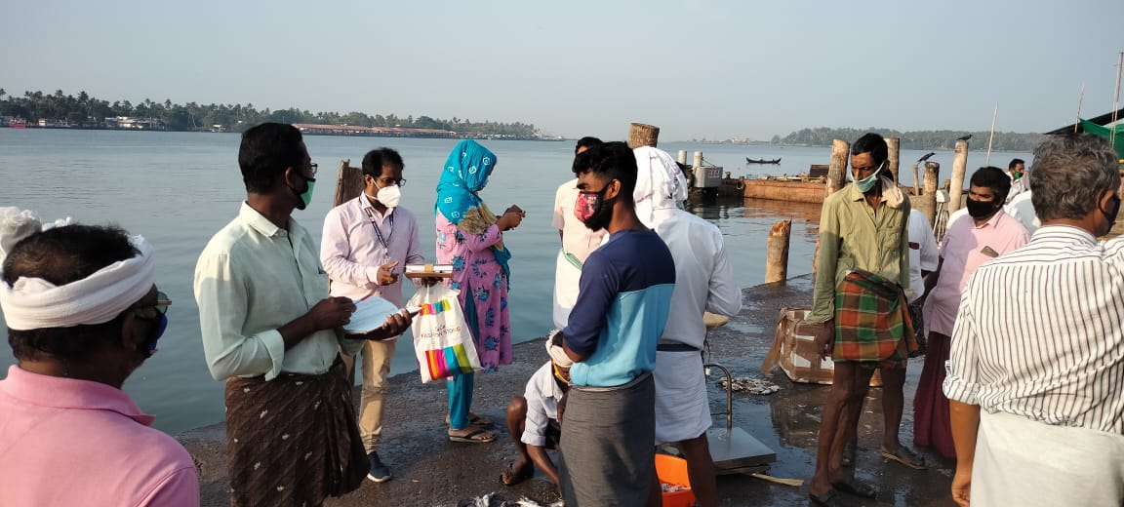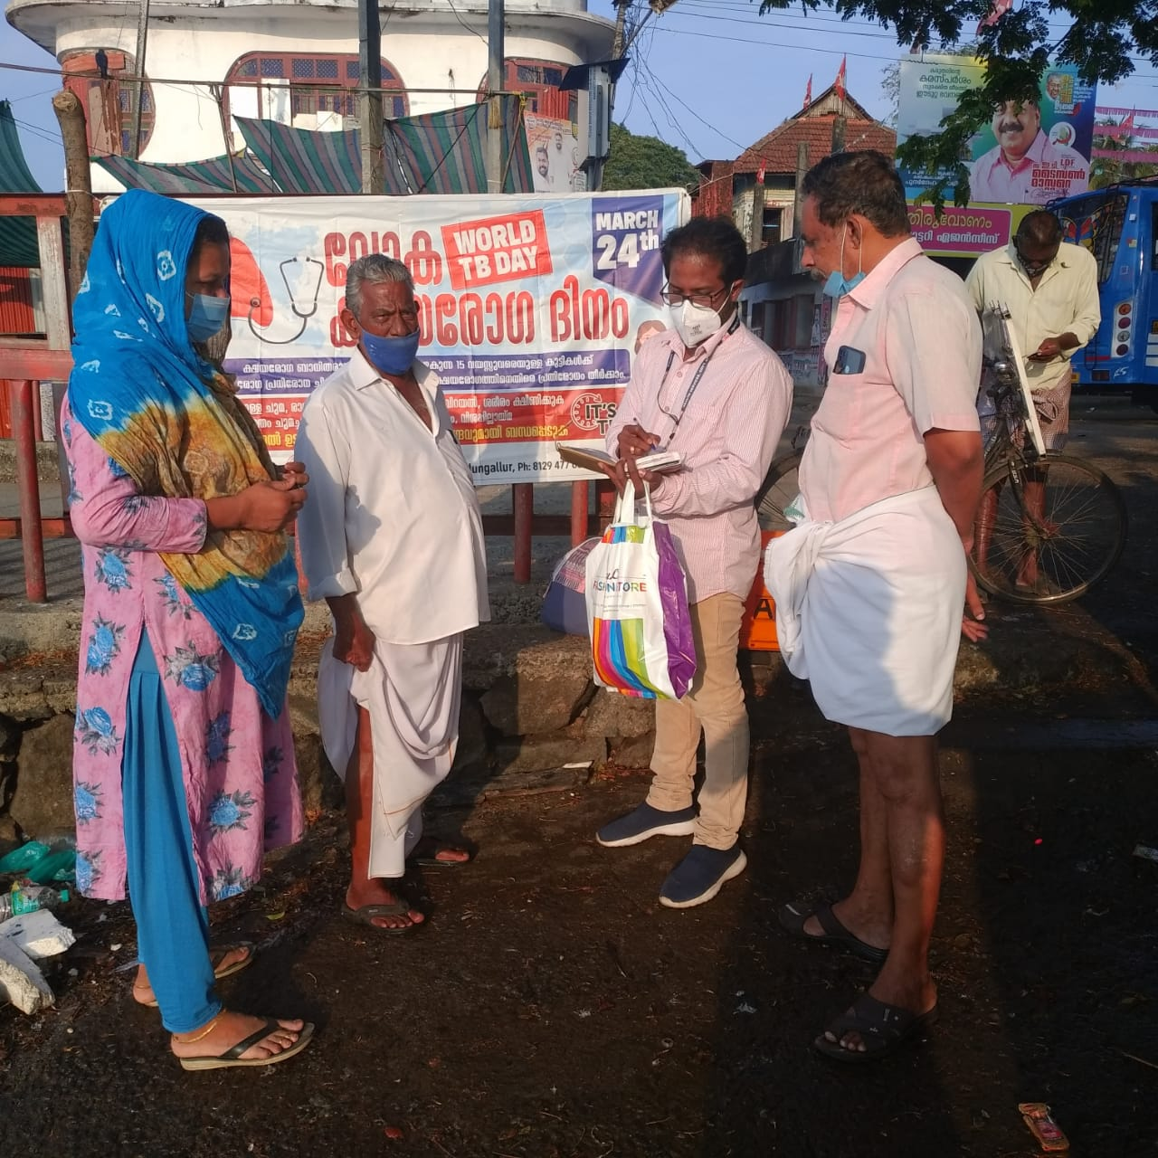
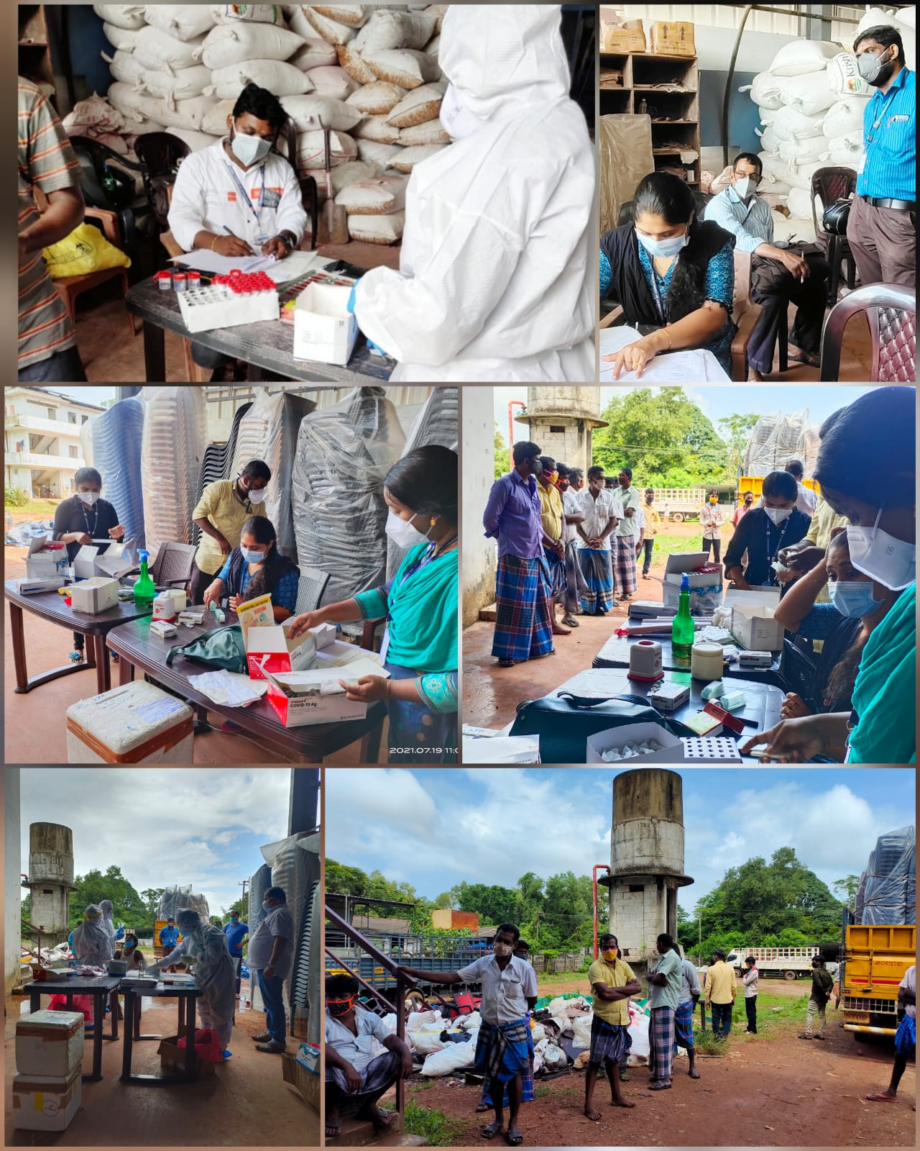
Prevention
Wayanad District

- Installation of large IEC boards in most remote tribal colonies of district.
- Distribution of large handkerchiefs in the beginning of the first wave of covid, in tribal colonies which share boarder with other states.
- Employing Hamlet Asha’s, that is the ASHA Workers from among tribal people, for field-based TB diagnosis and sputum transportation.
- Procurement of ART medicines from neighbouring district with the help of volunteers during the lock down phase of first wave of covid.
- Bidirectional TB screening of migrant workers along with covid screening at Bathery.
- Provision of TB awareness at covid help desk Bathery Taluk Hospital.
- Sensitization and training of tribal promoters or volunteers of tribal department in the last year.
- Field based TB diagnosis of Paraplegia patient by ASHA worker, the ASHA worker climbed a hill top and collected the samples which tested and diagnosed as TB.
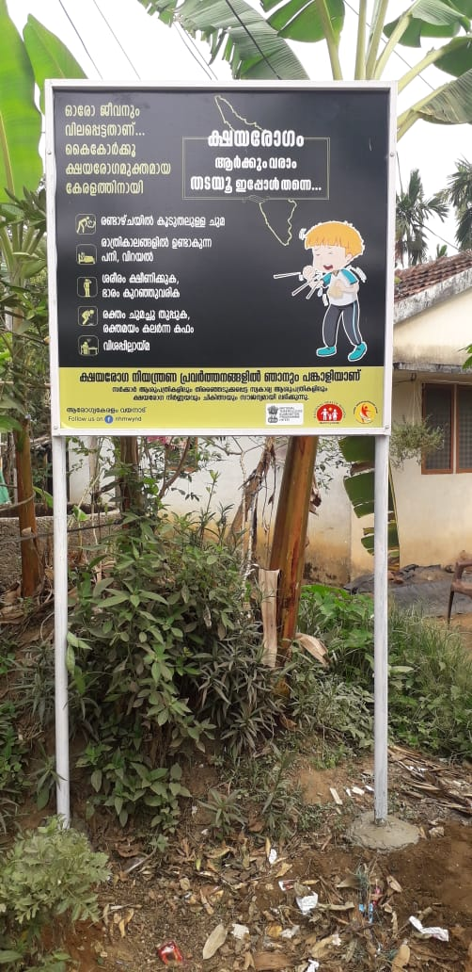
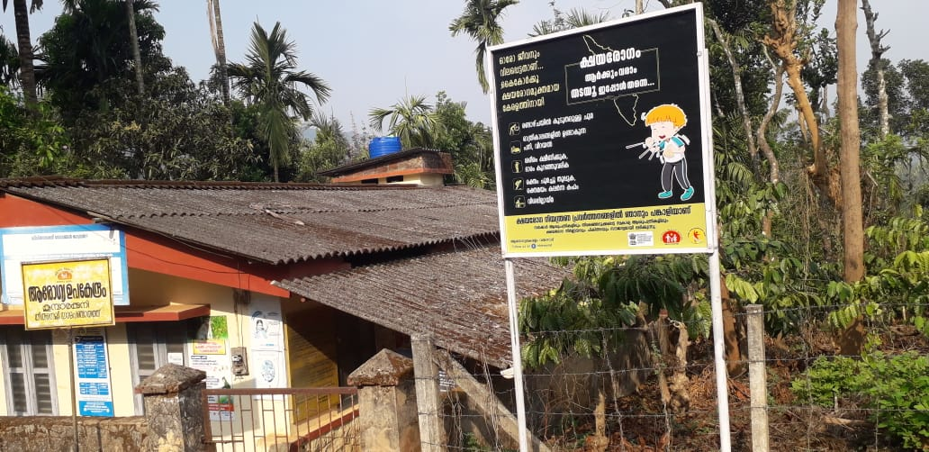
Prevention
Article 1

Kozhikode District

“KAIVALLYAM”- A MISSION TO REACH OUT TO TB PATIENTS WHO ARE ALCOHOL/DRUG ABUSERS.
District TB centre Kozhikode has a programme to reach out to drug and alcohol abusers among TB patients and also TB patients who need psychological help. This program is named as “Kaivallyam” meaning eternal peace. This is a comprehensive programme flagged out on February 2021 to strengthen support to such TB patients. It is a joint initiative of TB centre and OST centres under KSACS- KERALA STATE AIDS CONTROL SOCIETY. Programme was officially inaugurated on February 23 2021
Three counsellors from OST centre and MR Muhmmed Shihab the PPM coordinator At DTC who is also an experienced professional counselling are rendering their services voluntarily. Smt. Shilpa the STS DTC is in charge of arranging the Counselling sessions
1. A special medical camp was conducted for drug and alcohol abusers on 15/3/2021 at Konnad beach. District TB officer Dr. P. P. Pramod Kumar inaugurated the program.
2. In preparation to an understanding, a team lead by Dr. Jyothi S Ramachandran held a discussion with OST counsellors on 23 February 2021.
3. Three training sessions for NTEP KEY staff were conducted at DTC.
- “Tobacco abuse and health issues” by DR Jyothi S Ramachandran the Pulmonologist DTC on 7th June 2021.
- “Smoking Cessation” by Muhammed Shihab the PPM coordinator on 7th June 2021.
- “A professional approach to Counselling” by Ms Suchithra the Counsellor Medical College, Kozhikode on 22 July 2021.
4. Panel Discussion on Cyberchondria and TB on 29th July 2021
Four Intoxicating substance abusers were identified by TBHVs in the past four months.
Article 2

Treatment Adherence- A mild touch in the rehabilitation of street dwellers

Udayam project works for the rehabilitation of street dwellers in kozhokode district. It comes under social welfare department. District Collector is the authority in the district. Total Three “Udayam homes” in the district consists of four hundred inmates. There is a high possibility of easy spread of communicable diseases especially airborne infectious diseases including TB among the inmates. In a discussion by District Collector and District TB Officer, it is decided to undergo all inmates for TB screening and testing and giving awareness for home manager, medical officer, nurses, and all the staff. Both of these tasks were completed. District TB officer Dr. PP Pramodkumar inaugurated the TB screening and testing process on 28 May 2021. On july 29 2021 a zoom meeting was held for creating awareness among the staff of “Udayam home”. Previous to the camp a team under Dr. jyothi S Ramachandran visited the camp site. Senior treatment supervisor Shilpa NP monitored the screening. Different score was assigned to each inmate as per the possibility of TB. Gene expert was done at level two bio safety lab at Beach hospital, Kozhikode
Sent for LPA: 2 {1 recurrent}
Sensitive TB detected: 4
H mono drug resistant: 1

Total number of inmates screened: 400
Sent for microscopy: 249
Sent for gene expert: 96

Best practices & Innovations

Article 3

Kozhikode District

TB Laboratories and Diagnosis-Reaching out to Private NAAT sites
District TB centre has a plan to monitor drug resistant TB reports from private NAAT sites. Certain issues of not reporting or short reporting were noticed. Training (On Zoom) was given to microbiologists of private NAAT sites on 24 may 2021. The session discussed issues like:
- Ultra NAAT reports that comes from one site
- Some drug resistant cases are not duly reported to district TB centre. It leads to delay in treatment.
- If drug resistance is found in extra pulmonary cases and they discard the samples soon after the test, it faces the absence of samples to repeat the test in public sector lab.
Speaking on the training Pulmonologist and TB Elimination Medical Officer Dr. jyothi S Ramachandran conveyed them that UltaNAAT is not accredited and hence not recommended by NTEP. An SOP was made on procession and evaluation of Rif resistant TB. Twice in a week reporting format attached with this file) for all TB diagnosed was circulated among the participants. Each site owes to fill it and send to TB centre not to miss at least one Rif resistant case. Now two samples of extra pulmonary cases are collected at private NAAT sites and one is maintained for further investigation if needed.
Article 4

Prevention-
Covid-19 Vaccination drive to TB Survivors, TB and HIV
patients and their Family contacts

Government is always eager to give vaccination to the most deprived and vulnerable citizens of our Society. TB and HIV patients are among the most vulnerable category. Covid vaccination exclusively for TB and HIV patients is a felt need for a long time. Hence this programme was planned. At present it is only one of its kind in KERALA. Kozhikode Corporation Mayor Dr. Beena Philip officially inaugurates the program on 2 July 2021.
    - We are having two Vaccination camps in a week
    - Conducted Nine camps by July 30th 2021
    - Vaccinated 1000 Beneficiaries
    - Priority was given to TB patients including EPTB, HIV and PLHIV
    - Destitutes and Street dwellers

Best practices & Innovations

Article 4

Kozhikode District

Prevention- Extending NTEP services to Oncology patients

District TB centre Kozhikode joints with MVR Cancer centre and Research institute in catering NTEP services to cancer patients’.MVRCCRI is an initiative of CANCER AND ALLIED AILMENTS FOUNDATION, a non profitable charity organization .They are global leaders in cancer care and research. The institute is recognized as SIRO (SCIENTIFIC AND INDUSTRIAL RESEARCH ORGANIZATION) by the Department of Scientific and Industrial Research under Ministry of Science and Technology.
MVRCCRI has a 300 bedded cancer care hospital .They serve cancer patients right from diagnosis of cancer through their difficult journey through different phases of disease. They cater to cancer care of patients from northern districts of Kerala.They have different specialities from medical /surgical oncology, radiation Oncology to Paediatric Oncology.
Survival rate in various cancers has increased during the past years due to modern treatment modalities. Many Cancers like Head and neck cancer have an increased risk for developing TB and such cases have increased during the past few years.
District TB Centre in association with MVRCCRI arranged a Seminar on Cancer and TB on 15th July 2021.Speaking on the session Pulmonologist and TB Elimination Medical Officer Dr. Jyothi S Ramachandran urged them for the maximum utilization of NAAT availability for diagnosing suspected extra pulmonary TB cases, especially for Lymph nodes in various cancers that have a tendency to develop granulomas. This may help in diagnosis of EPTB that would have been missed as a cancer granuloma. Drug interactions, various cancer drugs and NTEP regimens were also a topic of discussion.
As NTEP is moving towards LTBI treatment, patients on immunotherapy and Haematological malignancies and Lymphoma may be tested with IGRA. District TB Officer Dr. P.P. Pramod Kumar assured that he will provide necessary ments for transportation of specimen to Govt NAAT sites. He urged them to use the Nikshay portal for notification. Dr Nirmal in department of Community medicine, and Dr Kavitha the HOD of Microbiology at MVR institute were selected as Nodal Officers in charge of STEPAS at MVRCCRI .TBHVs Mr Arundev and Mr Ashay were entrusted to give training on Nikshay portal and Data entry to Data entry operators at MVR.

Extending NTEP services to Oncology patients in MVR Cancer centre and Research Institute, Kozhikode
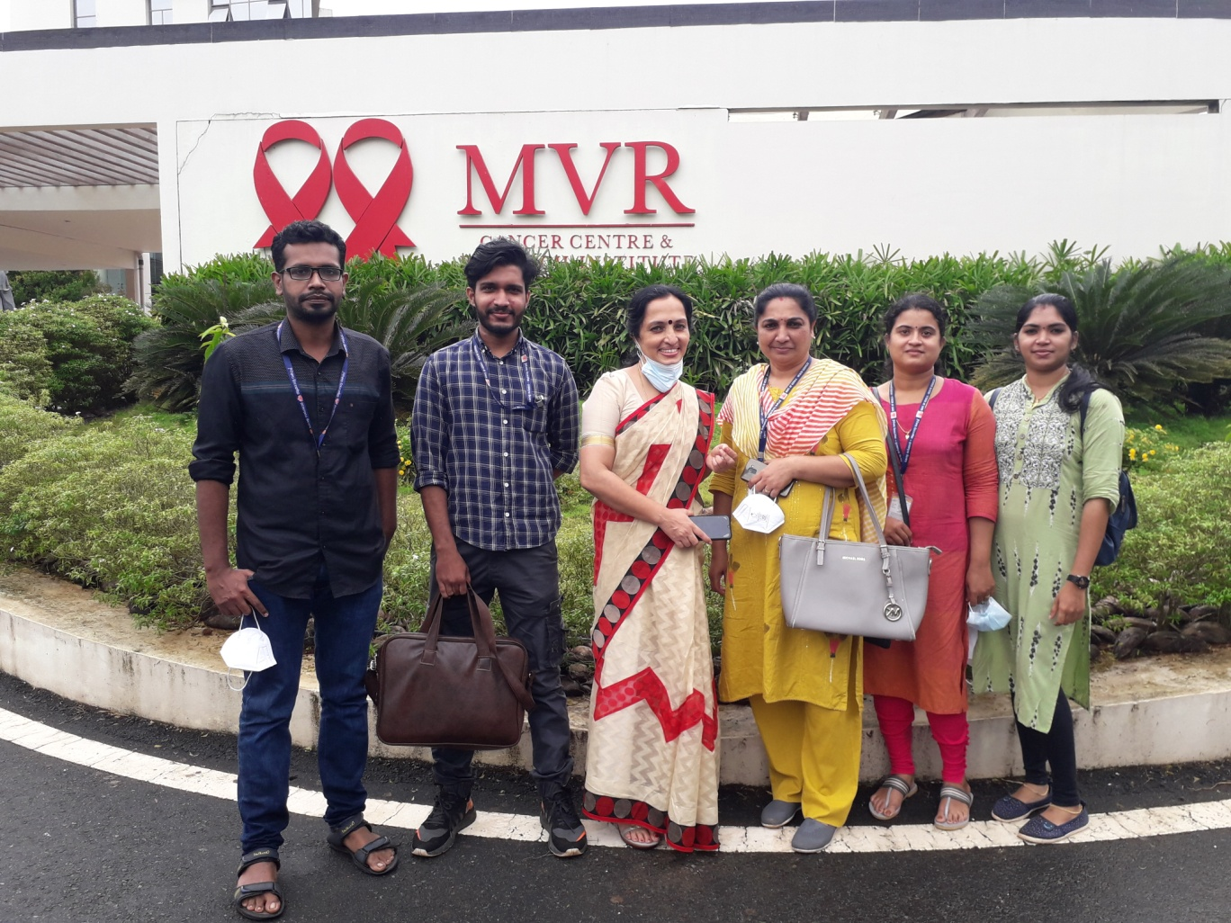
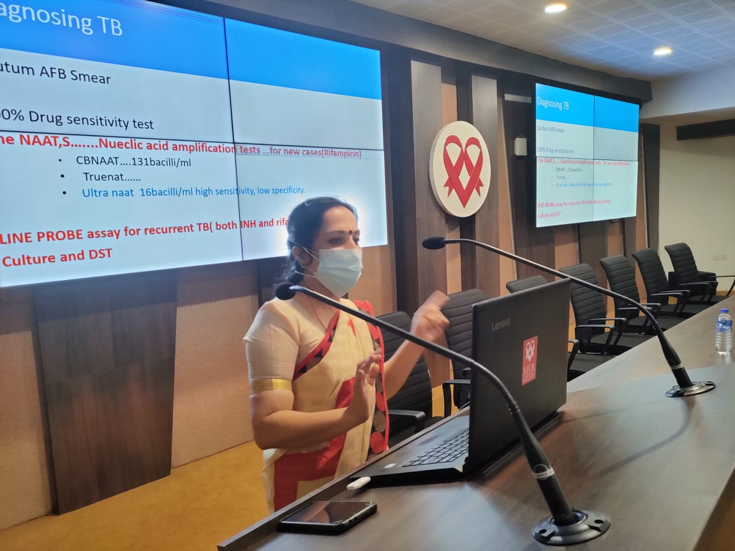
Kozhikode Corporation Mayor inaugurating Covid 19 Vaccination drive to TB Survivors, TB and HIV patients
Kaivallyam special medical camp inauguration at Konnad beach
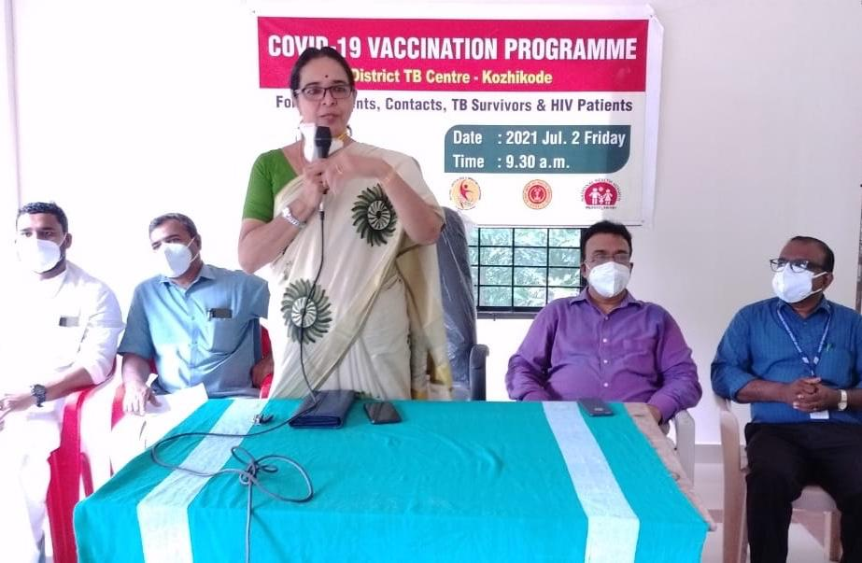
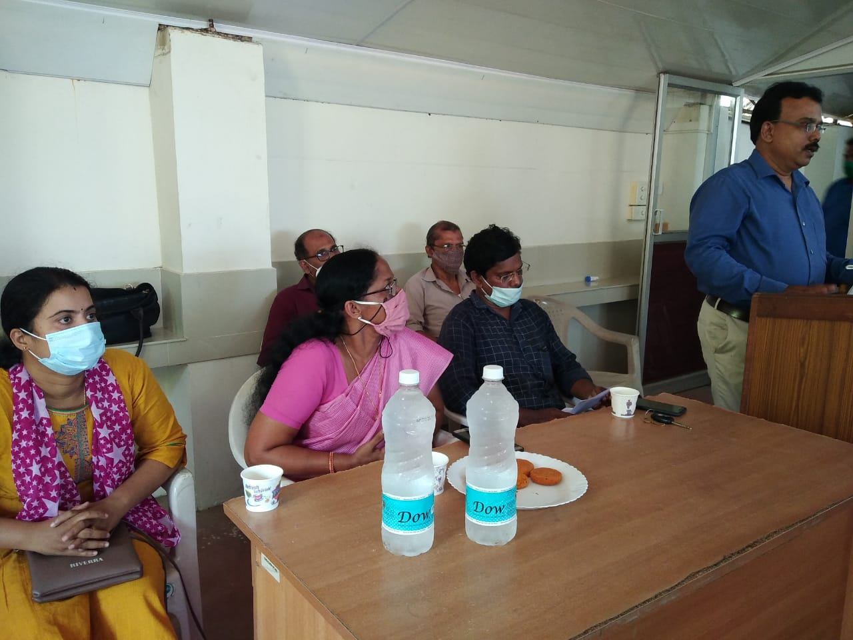
Glimpses of Best Practices, Kozhikode
Prevention

Kasargod District

During the COVID19 pandemic the whole health department acted with caution and sensibility. Besides covid the tuberculosis also a threatening disease. This covid time catalase the chances of spreading tuberculosis to the society. So Kasargod TB Centre, as the part of TB elimination activities, active case findings, TB-COVID19 bidirectional screening and TB awareness activities were conducted. In connection with active case findings Falcon tubes were distributed to the Covid testing sites and Vaccination site of District Hospital Kanhangad, Ukkinadukka Medical College, TATA Hospital Chattanchal, PHC Ennappara etc. TB covid bilateral sensitization has given to all private hospitals under the jurisdiction of Kasaragod TU. Distributed Medicine and Nutrition kit to the door step of the patient, also supplied Falcon tube for follow up examination.
- With the help of Cyber cell traced out an interrupted TB patient from Lathur district at Maharashtra.
- In connection with TB Covid comorbidity awareness, decided to set IEC Banner Paper and Form Board in all PHCs in the district.
- To reduce TB infection in HIV patients, Kasaragod TB Centre organizing facilitated activities and decided to set HIV TB IECs in 7 ICTC Centres, 9 FICTC centres and one STI clinic in the district.
- Kasaragod TB centre involving in the socio economic crisis of TB patients in the district. By the sincere approach of DTO and other staff, rehabilitated a TB patient in Old age home Kanhangad. Most of the TB Patients in Kasaragod district are in below poverty list. In this circumstances with the effort of DR TB co-ordinator a smart phone has given to the daughter of a tribal MDR patient. Also facilitated to get Ration card for one Migrant labour MDR TB patient settled in Kerala since last six years.
- When NTEP subnational certification survey conducted all over India Kasaragod was one of the selected district in Kerala State for the survey. Kasaragod participated to attain Bronze medal for Kerala through.

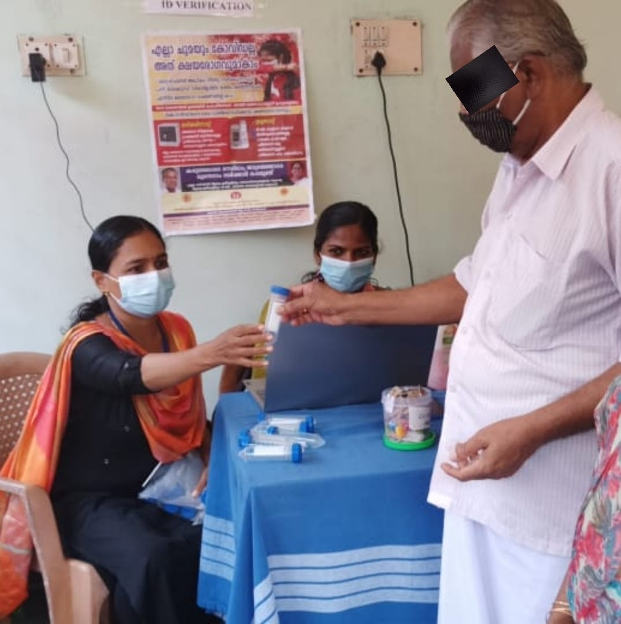
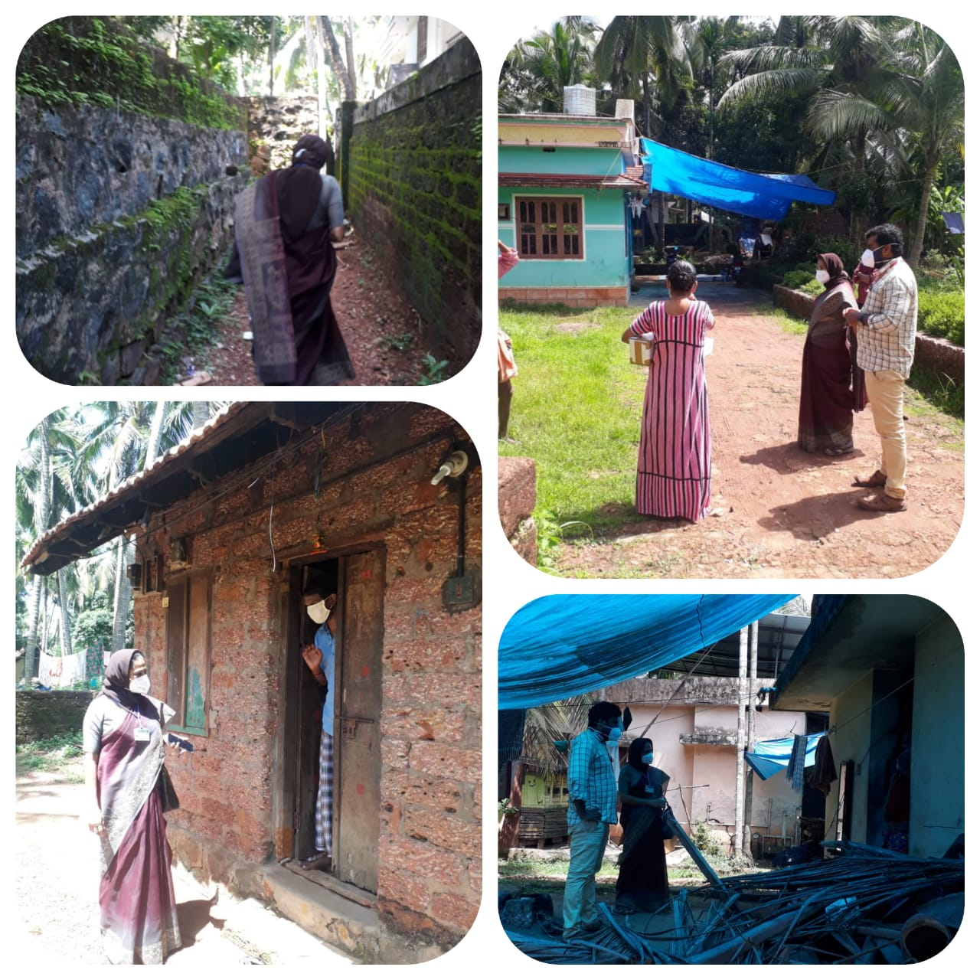
Glimpses of Best Practices, Kasargod

DTC KASARAGOD Medicine and Nutrition Kit Distribution - door step of Patient
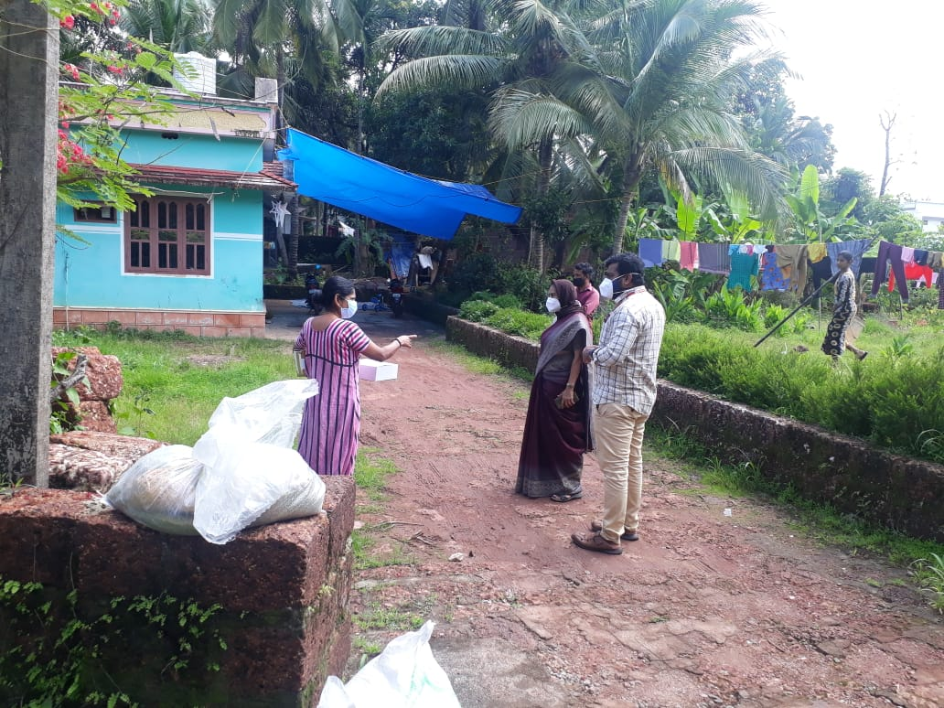
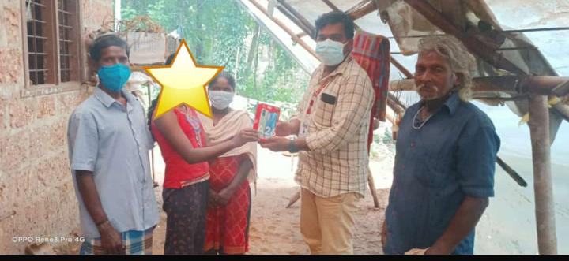
DTC KASARAGOD -Falcon Tube distribution at Covid Vaccination Site
DTC KASARAGOD - Falcon Tube door step of Patient
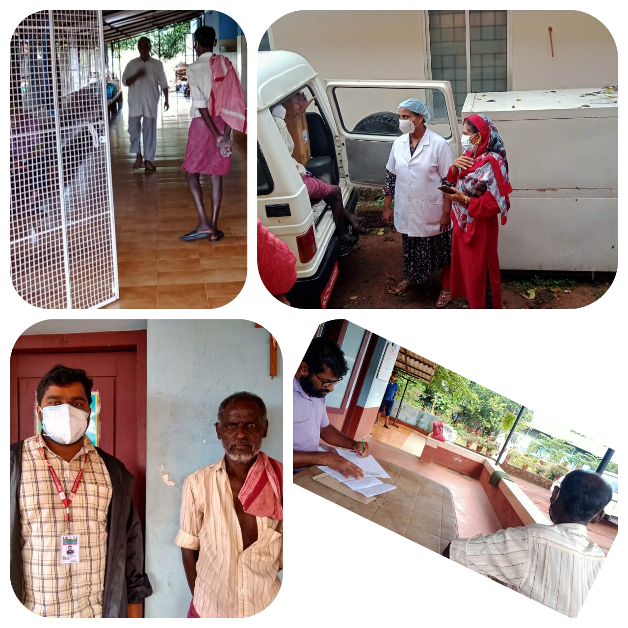
DTC KASARAGOD -PATIENT TO SNEHALAYA OLD AGE HOME
DTC KASARAGOD - Mobile phone to the daughter of poor MDR TB Patient

